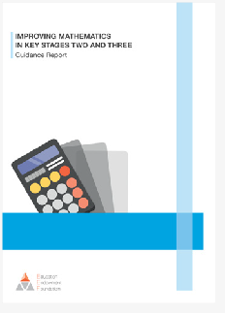







You can find the full report here: eef.li/ maths-ks2-ks3
Planning the learning
- Does anything need revisiting or re-teaching?
- What opportunities will there be to embed these ideas in future?
- When will we next meet the ideas
in this unit— can we build in opportunities for further practice?

Plan TASKS that could help
T
E
EXPLORE why these misconceptions persist
CONSIDER possible future issues
C
ADDRESS the misconceptions head-on
RESEARCH common misconceptions
R
A
Enter text here
- Bullet point

Enter text here
- Bullet point

Enter text here
- Bullet point

Enter text here
- Bullet point

Enter text here
- Bullet point

Understanding the issues
1
Addressing
assessment
2
Minimising misconceptions
INTEGRATING EVIDENCE INTO MATHS TEACHING
REACT to misconceptions
7 feedback
Focus on
Integrating evidence into maths teaching
3 through modelling
Making sense
6 problem solving
Guiding
4 rich network
Developing a
5 manipulatives
Making use of

