

You can find the full report here: [eef.li/ maths-ks2-ks3](https://eef.li/maths-ks2-ks3/)

**Planning the learning**

* Does anything need revisiting or re-teaching?
* What opportunities will there be to embed these ideas in future?
* When will we next meet the ideas

in this unit— can we build in opportunities for further practice?

**Plan TASKS that could help**

**T**

**E**

**EXPLORE why these misconceptions persist**

**CONSIDER possible future issues**

**C**

**ADDRESS the misconceptions head-on**

**RESEARCH common misconceptions**

**R**

**A**

Enter text here

* Bullet point­

Enter text here

* Bullet point­

Enter text here

* Bullet point­

Enter text here

* Bullet point­

Enter text here

* Bullet point­

**Understanding the issues**

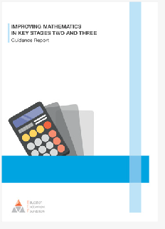

1

**Addressing**

**assessment**

2

**Minimising misconceptions**

**INTEGRATING EVIDENCE INTO MATHS TEACHING**

REACT to misconceptions

7 **feedback**

**Focus on**

**Integrating evidence into maths teaching**

3 **through modelling**

**Making sense**

6 **problem solving**

**Guiding**

4 **rich network**

**Developing a**

5 **manipulatives**

**Making use of**