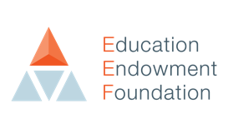
MOVING FORWARDS, MAKING A DIFFERENCE:
A planning template for schools—2022/23

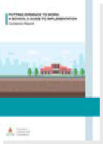
This tiered model is designed to enable school leaders to consider where best to invest time, energy and resources for the benefit of their particular pupils.
“The pandemic brought with it a period of huge disruption, but also, real innovation—with all school staff working tirelessly, despite their responsibilities expanding well past the norm, to meet the needs of their pupils”
Professor Becky Francis, CEO, EEF
“Schools should treat implementation as a major commitment and prioritise appropriately. Schools should probably make fewer, but more strategic, choices and pursue these diligently. Reviewing and stopping some existing practices may be required before delivering new ones.” Putting Evidence to Work: A School’s Guide to Implementation—EEF
1
2
3

To remove non-academic barriers to attainment, we plan to...
- Enter text here

3. WIDER STRATEGIES
To deliver impactful targeted support, we plan to...
- Enter text here

2. TARGETED ACADEMIC SUPPORT
To ensure access to high quality teaching, we plan to...
- Enter text here

1. HIGH QUALITY TEACHING

